***PROBLEM OF THE WEEK – 03***

***Assignment Given: 22/10/2020***

***Assignment Completed: 04/10/2020***

**PROJECT DISCRIPTION: Write or create a C++ application for the parsing an .html file and divide the data in html based on Passed, Failed, others status on different sheet in a single EXCEL file and perform operations.**

|  |
| --- |
| **Use-Case 1): function to take the user defined location and find the .html file to be parsed by the program.**  **Note: Takes a .html file location**  **Use-Case 2): Parses .html document and creates 3 sheets on the status of passed, failed, others.**  **Note:** all 3 sheets should be in one Excel sheet or CSV file.  **Use-Case 3):** the data or tuples parsed should be in the older of new one’s first or sort by Date.  **Note:** Sorting should be done by new to old based on date. |

**Note:**

1. Try to use the in-Built C++ functions and methods.
2. Use the command prompt to run the program as .exe and to perform operations.
3. Keep all files in one main directory and code.
4. Make all necessary comments and display message corresponding to invalid inputs.
5. Create an Log file for all the operations performed.

**Program Structure:**

------------------------------------**Schematic-**----------------------------------------

<Pre processor directives>

<type def>

<Template Function>

<Global Variables>

<Class Declaration>

**Public:** Parameters Declaration;

**Private:** Function Declaration ();

<Main()>

------------------------------------**Schematic**-------------------------------------------

**Program Definition:**

* Reading the directory User inputted and searching for Results.html
* Sending the path to object as parameter in constructor.
* Reading lines from html document as strings.
* Extracting the Comments from the <td> … </td> tags.
* Pushing the data to a structure.
* Sorting the structure based on date column.
* Writing into different .CSV files based on the Status value of the reading tuple structure.
* Closing the directory, files and creating a Logs for the given program.

**OUTPUT:**

**USE-CASE -01: (Checking without the .html file)**

* New Folder with .exe file.
* New Folder (2) without Results.html file.

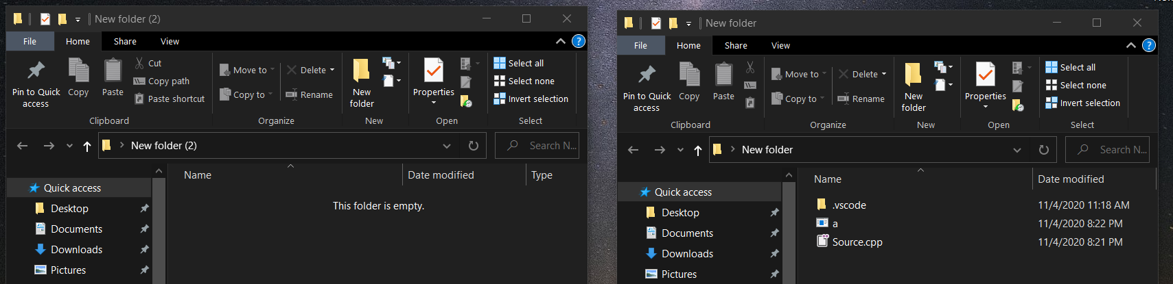

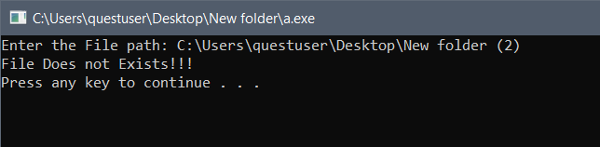

**USE-CASE -02: (Checking with the .html file)**

* New Folder with .exe file.
* New Folder (2) with Results .html file.

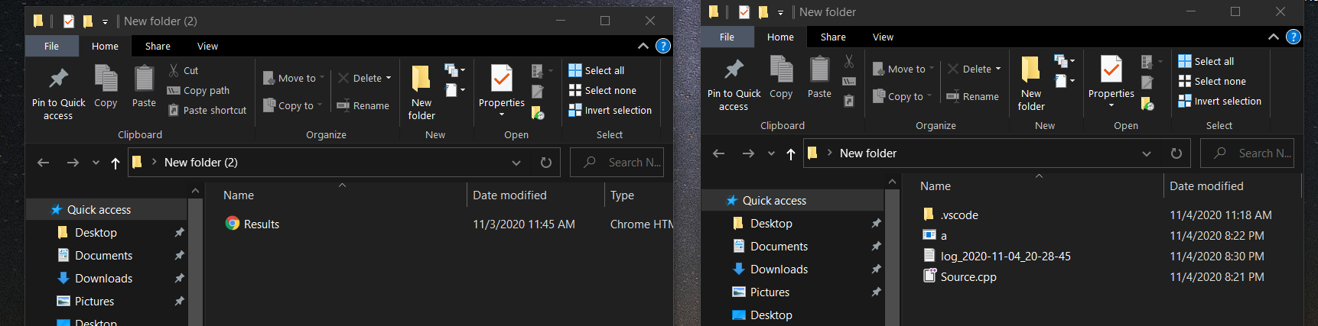

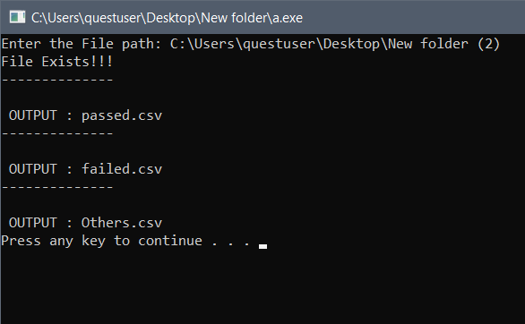

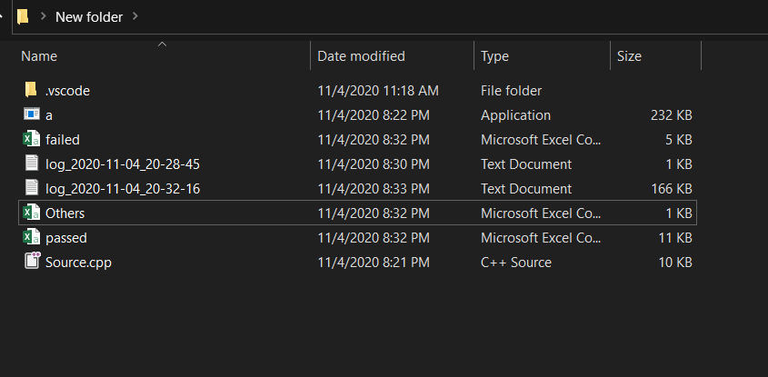

**LOGS:**

